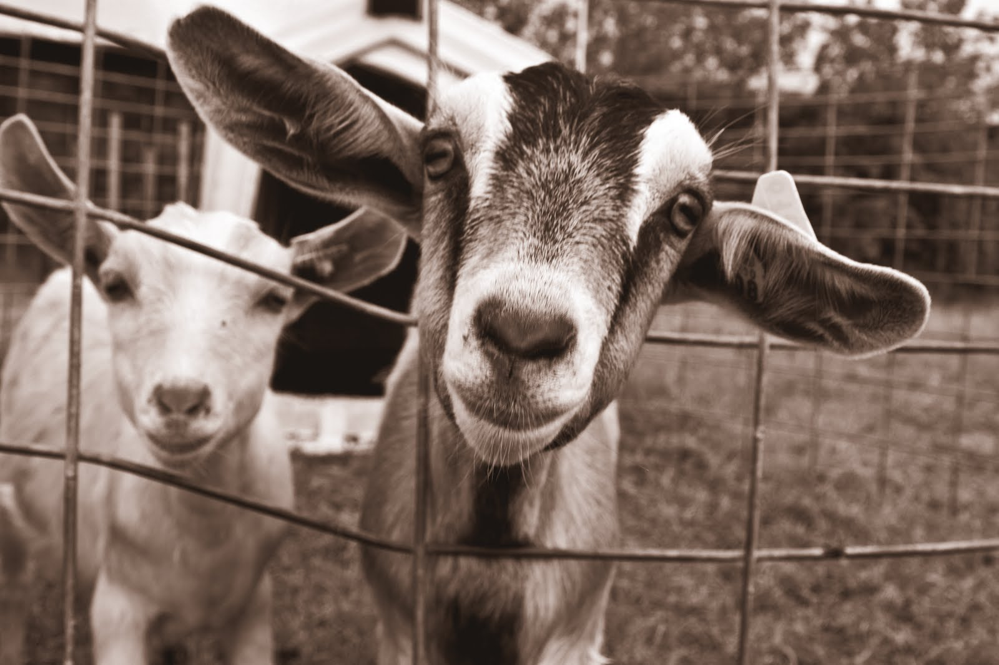
2020 Todd County Area Goat Workshop

November 5, 2020

12:00pm-2:00pm ct

register at: z.umn.edu/2020Toddgoat

Free to attend

The University of Minnesota Extension-Todd County will host the 2020 Todd County Area Goat Workshop, via webinar format, on Thursday, November 5th starting at 12:00pm (noon) CT. This workshop is intended for both dairy and meat goat producers.
This year’s producer spotlight will be Mark Buntjer of Buntjer’s RMR Livestock. The Buntjer’s have been raising both commercial and registered Boer goats for many years. They have exhibited goats at local and state shows and have explored various marketing outlets for their goats. Mark will be giving an overview and history of their farm, lessons learned along the way, and future plans for their operation. Farmers, 4-Hers, ag business professionals who work with farmers, and those interested in goats are invited to attend.

Speakers & Topics

Is Body Condition Loss Post-Kidding a Given? — Dr. Joe Armstrong-DVM, U of M Extension
Be Bold & Excite your Palate with Goat — Dr. Travis Hoffman, U of M/NDSU Extension
Animal Mortality & Proper Carcass Disposal — Troy Salzer, U of M Extension
Producer Spotlight: Buntjer’s RMR Livestock — Mark Buntjer, Long Prairie, MN

RSVP
Pre-registration is required. Please register at z.umn.edu/2020ToddGoat by 4:00pm CT on Wednesday, November 4th. The Zoom link will be emailed to you after registration closes. If you are unable to attend the live session, you will receive the recording via email. Any questions please contact: Brenda Miller at nels4220@umn.edu or 320-533-4655.

